What are the different stages of Software Development Lifecycle (SDLC) and how can QA contribute under each stage?

There are many software development life cycles and each of them achieve a certain goal. For example waterfall, V model, Iterative, Agile etc.Choosing life cycle depends on the needs of the project. And of course testing highly depends on the development activities.

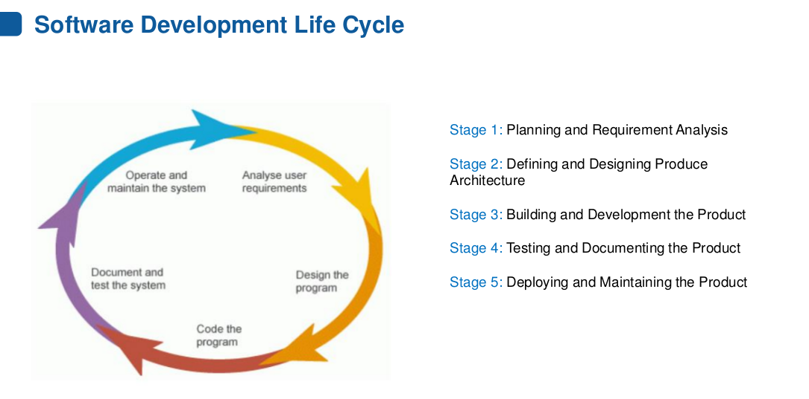

First stage of the development life cycle is Planning and Requirement Analysis. This is when requirements are clarified and analized. QA may do test planning and control activities during this phase. It is a good testing to have validation testing done during this stage. That is to check by reviewing requirements if application meets users needs or no, if it solves the problem.

After this comes Defining and Designing product architecture phase. During this phase qa may work on test plan, Test plan document is created to describe the scope approach, risks, objectives of testing, test approach, resources, test environment,test strategy, testing estimates, who will work on what part etc.

The next stage is Building and Developments stage. During this phase qa may work on creating test cases and setup the environment. There are many techniques that can be used to create test cases.

The next Stage is Testing and Docummenting stage test cases are being executed either manually or an automation script may be used to do it. Defects are logged in appropriate bug tracking system. Functional and non functional testing is done, as well as unit testing, mainly all types of testing.

During Deployment and Maintaining stage qa may evaluate exit criteria. Based on risk assessment we have set criteria which defines how much testing is “enough”. A test summary report can be created that may contain information concerning issues that have been raised and resolved and general info about testing.

And the last but not least is maintenance phase which includes maintenance testing appropriately, usually project closure meeting is organized to discuss lessons learned, what went good, what went bad to use the experience to improve process in the future projects.

These are actions that qa may do but are not obligatory. To sum up it is a good approach to have appropriate test activity for each development activity.